***Experiment 07***

***1)*** ***To Form a single network using a switch. Ping any 2 machines.***

***i) Network Topology***

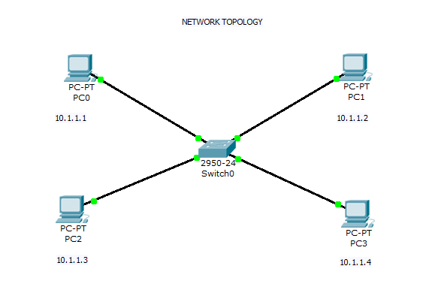

***ii) Output of : pinging 10.1.1.3 from 10.1.1.2***

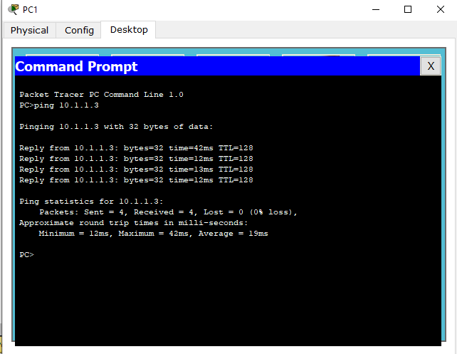

***iii) Simulation steps when sending packet from [PC-2] to [PC-1]***

***step1***

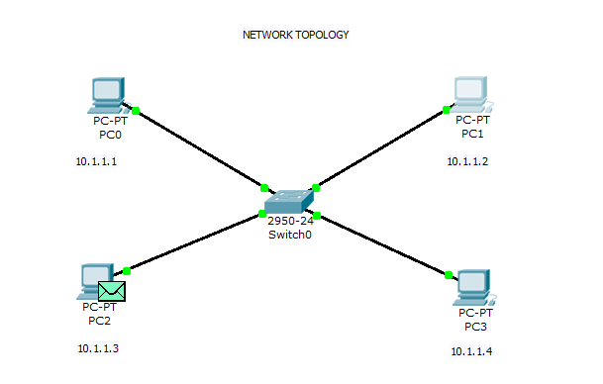

***step2***

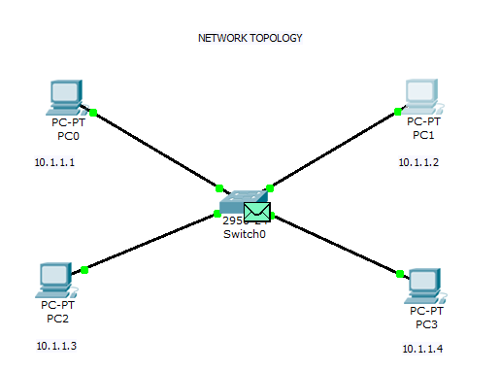

***step3***

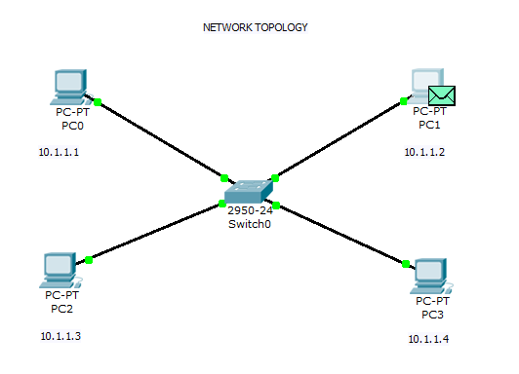

***step4***

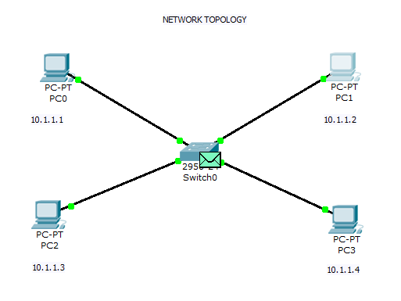

***step5***

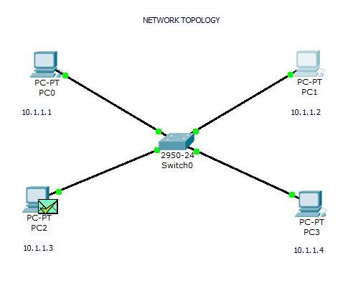

***2)*** ***To Connect 2 networks by making use of a router. Ping any 2 machines across the networks.***

***i) Network Topology***

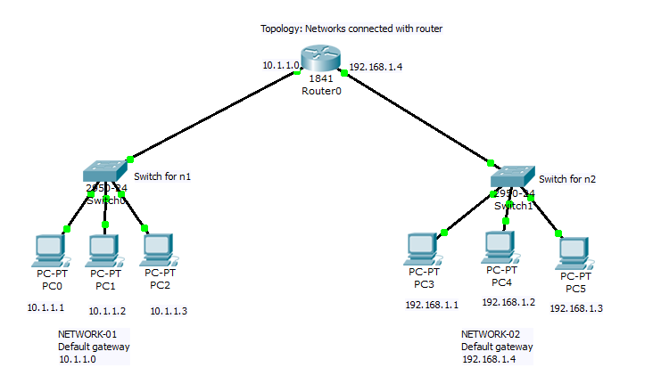

***ii)Output of : pinging 192.168.1.3 (NETWORK 2) from 10.1.1.2 (NETWORK 1)***

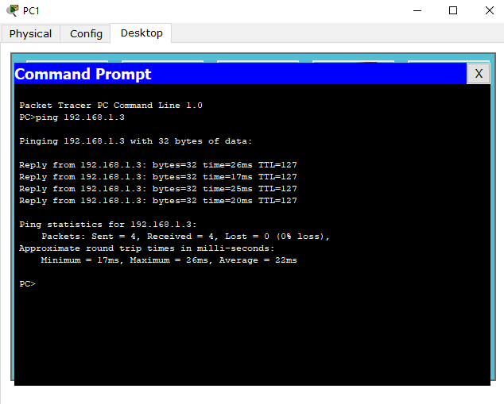

***iii) Simulation steps when packet sent from PC-1 [Network-01] to PC-5 [Network-02]***

***step1***

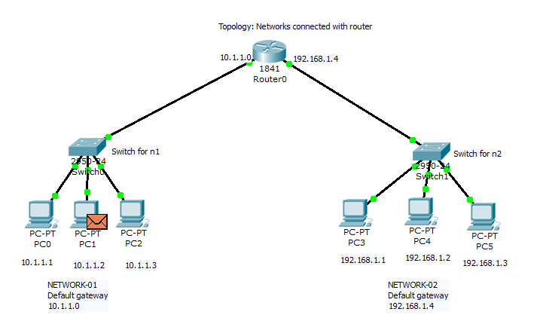

***step2***

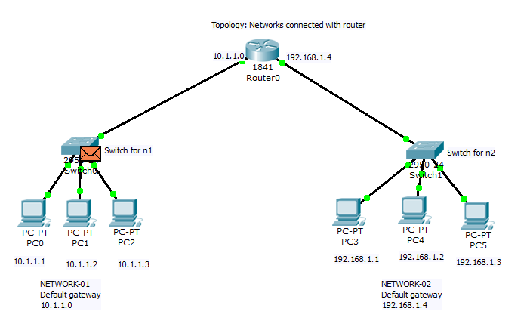

***step3***

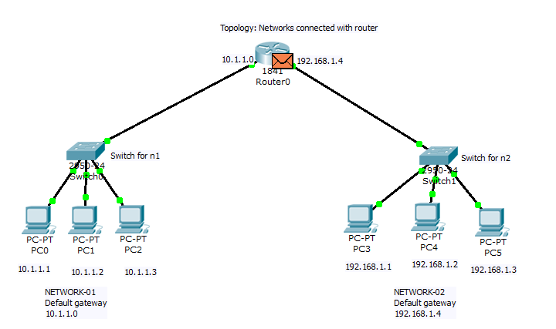

***step4***

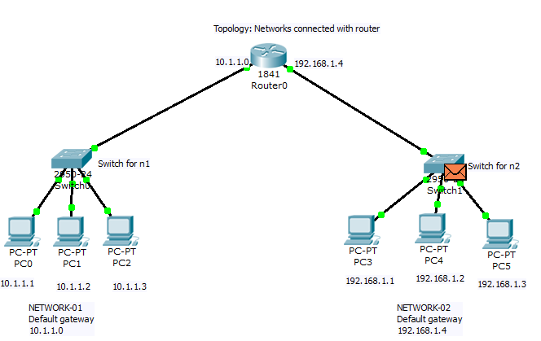

***step5***

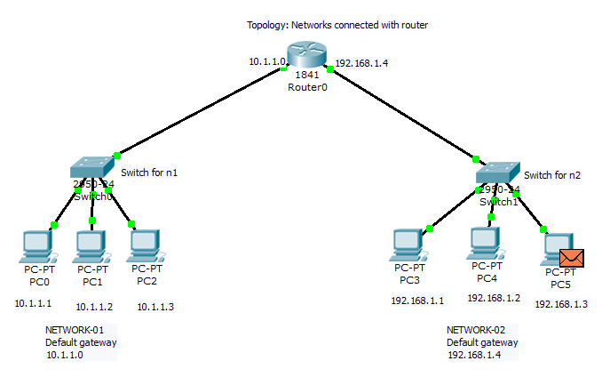

***step6***

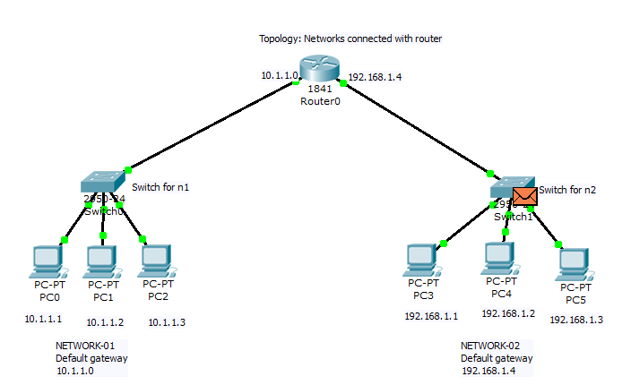

***step7***

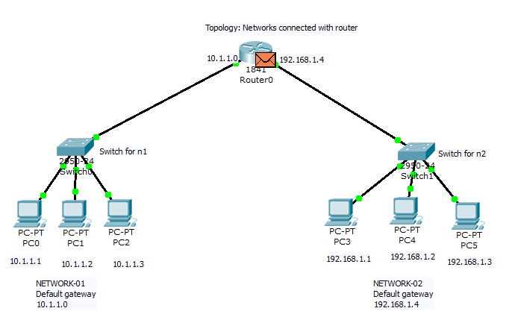

***step8***

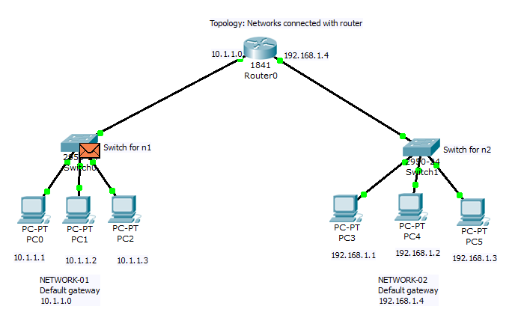***step9***

